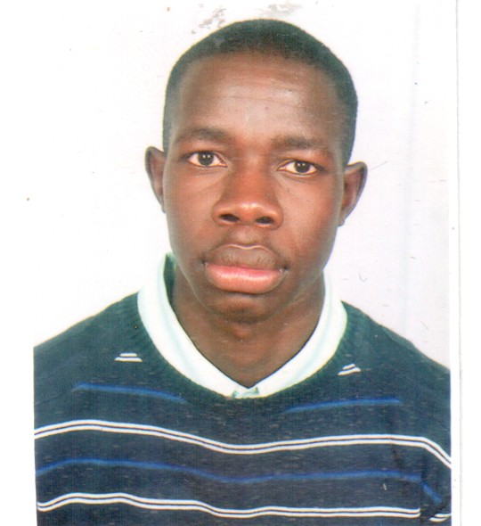
NAME. Omondi Vincent Opondo

VISION.
To provide an exceptional dining experience that satisfies my guests grown up taste by being a cut above in everything I do.
To provide happiness and joy to my guests through food, music and art.
KEYS TO SUCCESS
- Integrity
- Ethics
- Leadership
- Teamwork
- Training
- Recognition
- Communication
- Continuous improvement.
PROFILE.
- A self-motivated person, hardworking, Energetic, honest and a team player with capability to work under any working environment.
OBJECTIVE.
- To demonstrate high level on of culinary ethics while on duty and work with others to achieve a common goal.
- To find a challenging position to meet my competencies, capabilities, skills, education and experience.

PERSONAL INFORMATION
NAME : Omondi Vincent opondo.
NATIONALITY : Kenyan
SEX : Male
LANGUAGES : English & Kiswahili
MOBILE NUMBER: +254702649782, +254723730107
EMAIL ADDRESS: vomondi27@gmail.com

EDUCATION BACKGROUND.
- 2011-2014 Diploma in hospitality management at Mount Kenya University.
SUBJECTS COVERED INCLUDE.
  - Entrepreneurship
  - Customer care
  - Communication skills
  - Front office operations
  - Legal aspects
  - Computer applications
  - Marketing
  - Human resource
  - Food hygiene and micro-biology
  - Food production
  - Food and beverage service
  - First aid course
  - Disaster and conflict management

- 2010 Certificate information Technology with credit in desktop publishing, Microsoft word, computer literacy, spreadsheet and Microsoft excel. 2009 Sat for K.C.S.E

AWARDS.
- Diploma in hotel management 2014
- Certificate upon successful completion of an internship program at Flamingo beach Resort and spa
- Occupational First Aid certificate of merit
- Certificate of merit in information technology
- K.C.S.E Certificate
KEY STRENGTHS.
- Able to follow cash, credit and room charge procedures.
- Demonstrate ability of utilizing suggestive selling techniques.
- Highly skilled in taking food and beverage order correctly and in a suitable fashion and enter the orders into the online system.
- Technical i.e. MS word and excel.
- Possess high level of accuracy and attention to detail

WORK EXPERIENCE.
I have worked previously with ole-Sereni hotel, Nairobi Serena hotel and sarova Shaba in the restaurant and banquets sections performing tasks like,
-Take food and beverage orders to the guests without delay
-Pass orders to the kitchen staff and bartender
-Enter the order into the point of sale system to ask for food preparation
-Ensure correct and quick delivery of orders
-Anticipate guest needs.
-Accommodating guest at a function while circulating the room
Also trained at Flamingo beach resort and spa in various departments namely, kitchen all departments, restaurant service section, stores, front office and housekeeping, and wasini resort in wetlands and Sagana gateway resort in Nyeri as a wait staff on casual basis. In addition I have classroom experience attained during my three years of study in college. Currently I am working as a deli chef in one of the major retail super markets in Kenya called Tuskys.

HOBBIES.
- Nature Socializing- interact with the guests at all times and find out their areas of pain or complains
- Cooking- fuse local cuisines from the different cultures to generate one common dish that is common to all
-Travelling- explore areas of interest within different geographical positions just to appreciate.
REFEREES
- PETER MWANGI
OUTSIDE CATERING MANAGER NAIROBI SERENA HOTEL
- Mr. Simon Wamburu
HR TUSKYS SUPER MARKET
3. MADAM RUTH KWEYU
HUMAN RESOURCE MANAGER FLAMINGO BEACH RESORT AND SPA

